AI SDR / Lead Research Agent
B2B sales research automation · AI agent workflow
21 October 2026
Optimity Logics | info@optimitylogics.com

From a company URL to a reviewed draft, with nothing sent automatically
7  AI agent steps, one job each |  | 100  point lead score |  | 1  personalized draft email per lead |  | 0  emails sent automatically

1. At a glance
Item | Detail
Task | AI SDR / Lead Research Agent (B2B and SaaS sales)
What it does | Takes a company website URL, researches the company, finds a public business contact, identifies one main pain point, scores the lead out of 100, plans the personalization and writes a draft cold email. Everything is saved to Google Sheets
Built with | A webhook trigger, 7 AI agent steps and Google Sheets
Core idea | Each AI agent does one job and passes structured results to the next. Facts are kept apart from guesses, and a person reviews every email

2. The business problem
Good outbound sales starts with research, and research is slow. A sales development rep has to understand each company, find the right contact, work out a believable problem and write an email that does not sound generic. Under time pressure, emails become generic, and claims that cannot be backed up hurt trust.
The manual process today:
- Open the company website and note what the company does.
- Find a suitable contact and a public email address.
- Think about where the company may have a problem.
- Decide whether the company is worth contacting.
- Write a personal email.
- Log the lead in a sheet.

3. The solution
An automation that starts from a webhook carrying the company URL and moves through seven AI agents in order. The first two research the company and its public contact. The next two analyse the business and pick one pain point. Then the lead is scored, the personalization is planned and the email is drafted. The final step adds one row to Google Sheets with the status Pending and Not Sent.
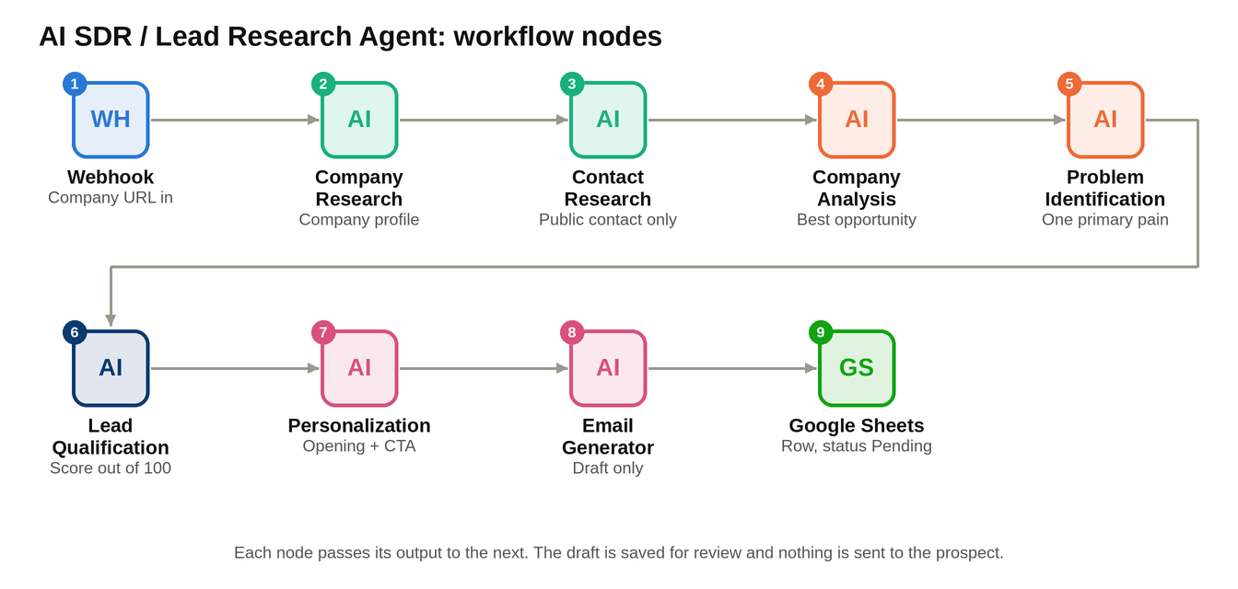
The workflow as nodes: nine steps in a straight line, from the company URL to the saved draft.

4. How it works
Part | Step | What it does
Start | 1. Webhook | Starts the flow and passes in the company URL
Research | 2. Company Research | Builds a profile as JSON: name, industry, products, customers, business model, size, operations and possible challenges. It keeps facts and observations separate and does not write a pitch
Research | 3. Contact Research | Looks only at public pages such as Contact, About, Team and Leadership. Prefers a founder, CEO or sales lead. Falls back to addresses like sales@ or info@. Never guesses an email, and returns null if none is public
Analyse | 4. Company Analysis | Finds manual, repetitive and information-heavy work and selects the highest value opportunity with supporting evidence. Inferences are treated as inferences
Analyse | 5. Problem Identification | Lists pain points with why it matters, business impact, evidence and confidence (High, Medium or Low). Selects one primary pain point
Write | 6. Lead Qualification | Scores the lead out of 100 and gives a qualification, a reason and a recommended sales angle
Write | 7. Personalization | Creates an opening observation, a problem hypothesis, a value proposition, a reason for contact and one low-friction call to action
Write | 8. Email Generator | Writes the subject and the email body. It is concise, has one call to action and makes no unsupported claims. It only drafts, it never sends
Record | 9. Google Sheets: Add Row | Adds one row with the company details, pain point, score, email draft and contact email

5. How leads are scored
The Lead Qualification agent gives each lead four scores of 25 points each. It is told not to inflate the score and to base it only on the research.
Factor | Max points | What it measures
Business relevance | 25 | How well the company fits a B2B or SaaS conversation
Problem relevance | 25 | How relevant the identified pain point is to this company
Potential business value | 25 | How valuable it would be to solve the problem
AI and SaaS opportunity | 25 | How likely an AI or software solution could help

Total score | Qualification
80 to 100 | Strong Fit
60 to 79 | Moderate Fit
0 to 59 | Low Fit

6. Rules the agents follow
- Never invent facts, and never state an assumption as a fact.
- Mark anything inferred as an inference, and label pain points with a confidence level.
- Research steps only research. They do not pitch or write emails.
- Contact details come only from public pages of the company's own website. Emails are never guessed or built from patterns.
- The email must not use fake urgency, exaggerated claims, emojis or more than one call to action.
- The email must not mention that AI wrote it.
- Every agent returns JSON only, so the next step can use the result.

7. Data saved to Google Sheets
Each lead adds one row with: company URL, company name, industry, description, products and services, target customers, business model, geographic focus, company size, business operations, operational challenges, AI and automation opportunities, primary pain point and its reason, total score, qualification and its reason, opening observation, email subject, email body and the contact email.
Two status columns are set automatically to Pending and Not Sent.

8. Tools and technologies
Tool | Used for | Why
Webhook | Starting the flow with a company URL | Any form, sheet or app can trigger it
AI agents (7) | Research, analysis, scoring and writing | One clear job per agent keeps each answer focused and easy to check
Google Sheets | Lead record and review queue | Simple, visible and easy for sales to filter

9. Scenarios the workflow is built to handle
These describe the designed behavior. Test results are not part of this document.
Scenario | Designed behavior
Company with clear public information | Full profile, a specific pain point, a score and a personal draft email
Company with little public information | Fewer facts, more observations marked as inferences, and lower confidence
No public contact email | Contact email is returned as null. The team finds one manually
Weak fit company | The low score and the reason are recorded with the lead

10. Human approval and safety points
- The email is only a draft. The status starts as Pending and Not Sent.
- A person reviews each email before anything reaches a prospect.
- Only public business information is used, and emails are never guessed.
- Claims in the email must be backed by the research.
- Confidence levels and the fact versus inference split help the reviewer judge each point.

11. Limitations and what production needs
- This document has no recorded test results. Run the scenarios in section 9 on real companies first.
- In the exported file the workflow is off and its steps are paused.
- The flow has no branch on the score. A Low Fit lead still gets an email draft.
- There is no sending step. Approval and sending are manual for now.
- Contact name, role and source link are found but not saved to the sheet. Only the contact email is.
- Research quality depends on the AI being able to read the company website.
- The editor flags warnings on the Problem Identification, Lead Qualification and Google Sheets steps. These should be checked before go-live.
- There is no duplicate check, so the same company can be added twice.
- Cold outreach and contact data may be covered by local privacy and email rules, which should be reviewed.

12. Key learnings and improvements
- One job per agent. Small steps are easier to check and fix than one long prompt.
- Facts and inferences stay separate. This keeps the email honest and gives the reviewer something to verify.
- Draft first, send later. A review step protects the brand and the prospect.
- Next improvements: skip the email for Low Fit leads, add an approval and send step, save the full contact details, add a duplicate check, sync to a CRM and add follow-up emails.
Optimity Logics | Email: info@optimitylogics.com

